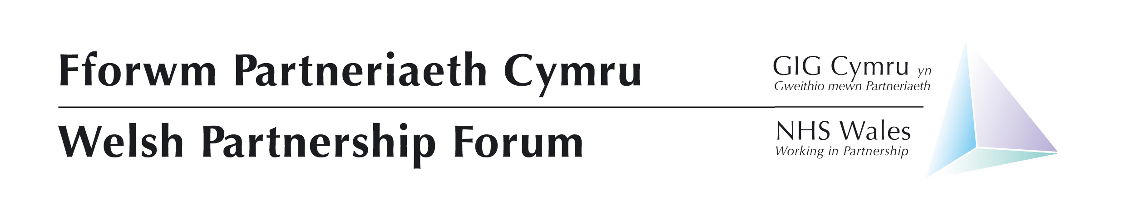
Microsoft Teams Call
Or,
Dial in – 0203 321 5250
ID: 656 550 286#

Full meeting: Wed 6 April 2022 13:30 – 17:00

Agenda Item No. | Agenda Item | Lead | Style of Report | Doc No. | Start Time | Time allocated
Welcome and Apologies
1 | Nicky Hughes to chair – include clearing of previous WPF note & actions | Nicky Hughes | Verbal & Paper | 01.1 | 13:30 | 5 mins
2 | Current Position | Judith Paget | Verbal |  | 13:35 | 10 mins
Strategic – Items for Discussion
3 | NHS Wales – A Plan to Transform Planned Care Services and Reduce Waiting Times | Nick Wood | Paper | 03.1 | 13:45 | 30 mins
4 | Vaccines | Elin Gwynedd | Verbal |  | 14:15 | 10 mins
5 | Occupational Health Review | Sara Whittam | Presentation | To Follow | 14:25 | 10 mins
6 | Workforce Race Equality Standard | Rebecca Gorman | Presentation | To Follow | 14:35 | 10 mins
7 | Staff Survey | Rhiannon Windsor | Paper | 07.1 | 14:45 | 10 mins
15 Minute Break
8 | Health and Social Care Workforce Strategy | Alex Howells & Julie Rogers | Paper & Workshop | 08.1 | 15:10 | 60 mins
NHS Policies and Contracts
9 | General Policy update | Andrew Davies | Paper | 09.1 | 16:10 | 5 mins
For Information
10 | NHS Staff Council Update | Attendees | Verbal |  | 16:15 | 5 mins
11 | Social Partnership and Fair Work | Amber Courtney | Presentation | 11.1 | 16:20 | 10 mins
12 | Staff Governance Framework | Helen Thomas | Verbal |  | 16:30 | 5 mins
Any other business
13 | Nothing currently raised. | Nicky Hughes | Verbal |  | 16:35
14 | Future WPF Meetings  - 6 July 2022  - 17 November 2022 | Nicky Hughes | Verbal |  | Close

