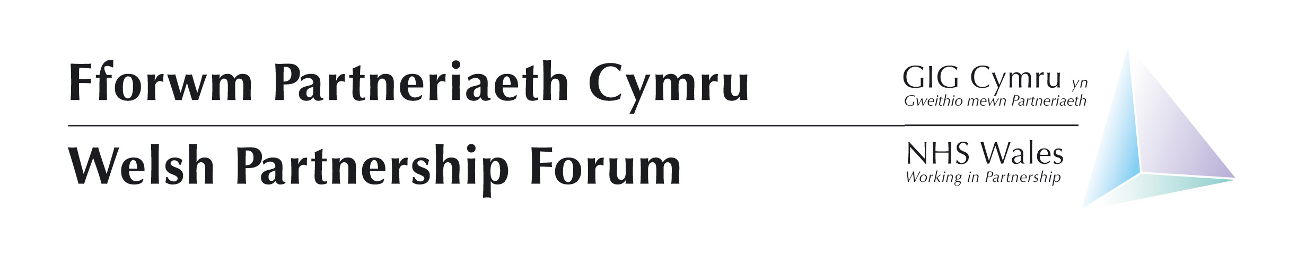
Swansea Stadium (Liberty)
Plasmarl, Swansea SA1 2FA
17th November 2022
Trade union pre-meeting: Vetch Field Lounge 10:15 – 11:15;
Employers and Welsh Government pre-meeting: Centenary Suite 10:30 – 11:15
Full meeting: 11:30 – 15:30

Agenda Item No. | Agenda Item | Lead | Style of Report | Doc No. | Start Time | Time allocated
Welcome and Apologies
1 | Alex Howells To chair – include clearing of previous WPF note & actions | Chair | Verbal & Paper | 01.1 | 11:30 | 05 mins
2 | Current Position (Including NHS Executive) | Judith | Verbal |  | 11:35 | 10 Mins
Strategic Items
3 | Winter  - Winter Planning  - Covid Vaccine Programme  - Testing | Samia Edmonds  Chris Jones  Stacey-Jo Smith | Verbal  Verbal  Verbal |  | 11:45  11:55  12:05 | 10 mins  10 mins  10 mins
4 | Health and Social Care Workforce Strategy Update | Angie Oliver | Paper | 04.1 | 12:15 | 5 mins
5 | Workforce Implementation Plan | Helen Arthur / Emma Coles | Workshop |  | 12.20 | 40 mins
6 | Social Partnership Bill Update | Neil Surman | Paper | 06.1 | 13:00 | 15 mins
Lunch – 13:15 to 14:00
Business Items
7 | Occupational Health Review Update | Sara Whitham | To note | 07.1 | To note
8 | Privatisation of NHS services | Richard Munn | Verbal |  | 14:00 | 5 mins
9 | Industrial Action | Nicky Hughes / Helen Arthur | Verbal |  | 14:05 | 5 mins
10 | WPF 2023  Review Terms of Reference, ways of working, priorities for 2023 | Chair | Workshop | 10.1  10.2  10.3 | 14:10 | 45 mins
NHS Policies and Contracts
11 | General Policy update | Andrew Davies | Paper | 11 | 14:55 | 5 mins
12 | Annex 21 – NHS Wales Guidance | Andrea Thomas | Paper | 12 | 15:00 | 5 mins
For Information
13 | NHS Staff Council Update | Nicky Hughes / Richard Tompkins | Verbal |  | 15:05 | 5 mins
14 | Welfare Project Update | Martin Mansfield | Paper | 13 | 15:10 | 5 mins
Any other business
15 | Nothing currently raised. | Chair | Verbal |  | 15:15 | 5 mins
16 | Future WPF Meetings for 2023  - 22 March  - 13 July  - 16 November | Chair | Verbal |  | 15:20

